Chapter 7, Problem 48.

Find v(t) and i(t) in the circuit of Fig. 7.115.

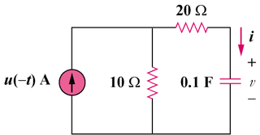

Figure 7.115
For Prob. 7.48.

